Title: Cost-Effectiveness Analysis of Vaccination Program
Author: Mansimran Singh Miglani
Date: December 2025

Introduction
Health Problem
In order to avoid infectious diseases, which continue to be a major source of neonatal and infant morbidity and mortality worldwide, vaccination programs are an essential public health intervention. A typical PCV (Pneumococcal Conjugate Vaccine) -preventable disease with quantifiable healthcare and social costs is represented by the Streptococcus pneumonia infected disease modelled in this project. The data is inspired to replicate a large scale pharmacy dataset, but the study recognizes the associated limitations to its applicability, correctness and generalizability for real application due to limited data, lack of accounting of confounding variables and thus a lack of sensitivity analysis.

Relevance to Health Economics and Policy
To effectively allocate scarce healthcare resources, it is essential to comprehend the cost-effectiveness of vaccination. Health economists and policymakers can make well-informed decisions about vaccine deployment, financing, and prioritization within national health programs by analysing costs, cases avoided, and health outcomes.

Purpose of the Analysis
The goal of this study is to use a mimicked real-life inspired dataset to measure the health and economic effects at the most foundational level of a vaccination campaign conducted at a local pharmacy in Amritsar, India. The purpose of analysing data set from a local pharmacy is to look beyond business viability, profitability and thus monetary efficacy of a vaccination program. In order to determine if the intervention is a cost-effective method of disease prevention in a wider global perspective, the analysis computes net costs, treatment costs avoided, total vaccination costs, and the cost-effectiveness ratio, to elucidate the impact vaccinations and similar disease preventive interventions may have on a national/global scale.

DISCLAIMER
The data is realistically altered to maintain confidentiality and data privacy regulations. This study has been conducted with aims to appreciate socio-economic considerations that come in play at a much larger scale, beyond what a single local pharmacy data can tap into. This study does not intend to infringe upon copyrights of any institution, establishment or governing agency, nor does it claim accuracy of its findings. This study is all but an aim to showcase a glimpse of statistical and analytical prowess that goes into approving a health treatment option with context beyond improving patient treatment outcome, factoring in financial and regulatory variables. This report is a synthesis of the methods and self-deduced interpretations of results generated through the enlisted methods while upholding strict data management and privacy practices. This report recognizes the nuanced nature of real world setting, the variables that need accounting for and equitable representation, admitting its consequent limited accuracy. However, the study aims for the readers to appreciate the analysis that encompass the monetary side of things, a glimpse of what actually goes into deeming whether an intervention is worth economically at a national and global scale.

Methods
1. Data Source
- Dataset: vaccination_inputs.csv
- Key Parameters: population size, vaccine cost per person, administration cost per person, treatment cost per severe case, baseline disease incidence, and vaccine efficacy. These parameters were extracted to model costs and health outcomes associated with the vaccination program.
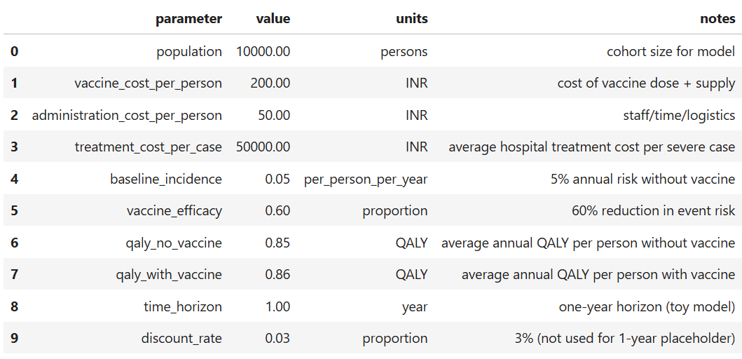
2. Analysis Steps
- Calculate Total Vaccination Cost: Multiply population by vaccine and administration costs.
- Estimate Cases Prevented: Apply vaccine efficacy to the baseline incidence.
- Compute Treatment Costs Averted: Multiply cases prevented by average treatment cost per case.
- Determine Net Cost: Subtract treatment costs averted from total vaccination cost.
- Calculate Cost-Effectiveness Ratio (CER): Divide net cost by cases prevented to obtain cost per case prevented.
3. Software and Tools
- Python: Used Pandas for data manipulation and Matplotlib for visualization.
- Excel: Tabulated results for clarity and reporting purposes.
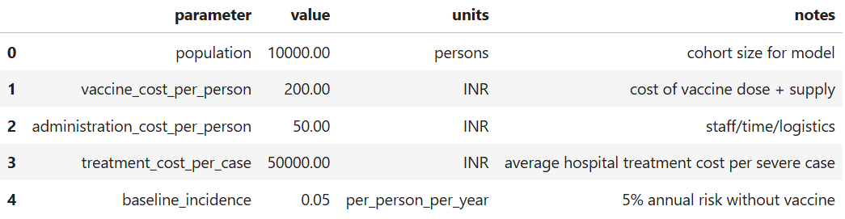

Results
1. Total Costs and Cases Prevented
- Total Vaccination Cost: INR 2500000
- Estimated Cases Prevented: 3%
- Treatment Costs Averted: INR 15000000
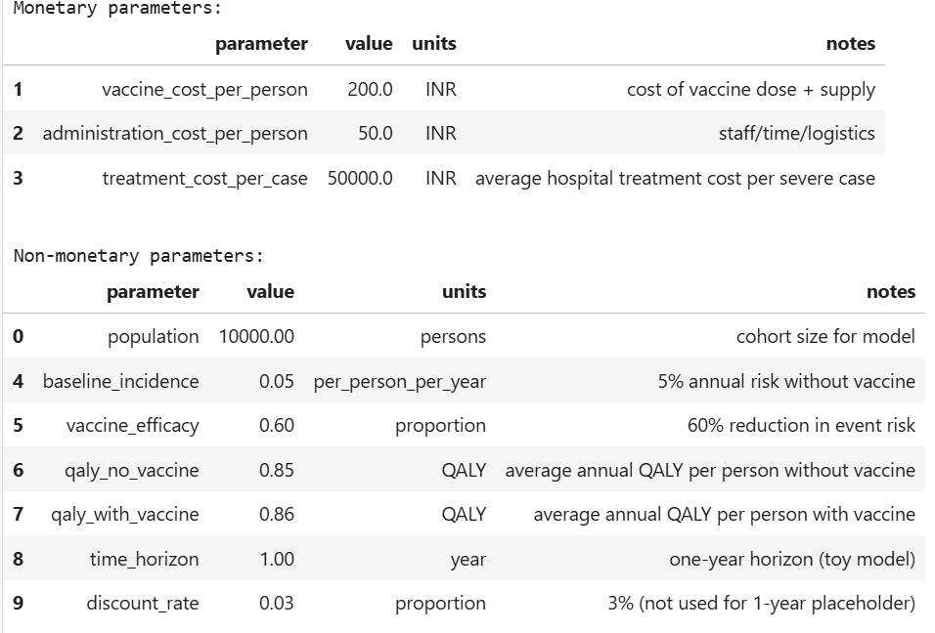

2. Net Cost and Cost-Effectiveness Ratio (CER)
- Net Cost of Program: -INR 12500000
- Cost-Effectiveness Ratio (CER): -INR 41666.67 per case prevented
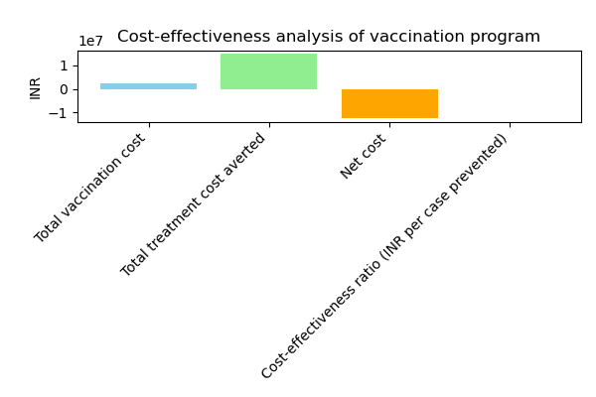

4. Summary Table of Economic Metrics
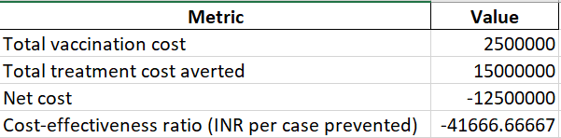

Discussion
1. Interpretation of Results
- The vaccination program demonstrates a net cost of -INR 12500000 and a cost-effectiveness ratio of -INR 41666.67 per case prevented.
- The analysis indicates that treatment costs averted exceed vaccination costs, suggesting that the intervention may be cost-saving or highly cost-effective, depending on context and willingness-to-pay thresholds.
- The results highlight the potential for economic and health benefits, reinforcing the value of preventive interventions in resource-limited settings.

2. Policy Implications
- These findings can guide policy-makers and healthcare planners in deciding whether to implement or scale vaccination programs.
- Cost-effectiveness evidence supports budget allocation decisions and informs national immunization strategies.
- Demonstrates the role of health economics in evidence-based decision-making, linking financial planning with population health outcomes.

3. Limitations
- Simplified local dataset and one-year horizon may not capture long-term health and economic outcomes.
- Real-world factors such as vaccine uptake rates, distribution costs, and indirect costs are not included, thus a robust sensitivity analysis cannot be conducted effectively.
- Assumptions regarding vaccine efficacy and treatment cost may vary regionally, affecting generalizability.

Conclusion
- The vaccination program is likely to be economically beneficial, preventing a substantial number of cases while potentially saving on treatment costs.
- Cost-effectiveness analysis, even in a simplified model, provides actionable insights for public health decision-making.
- Project demonstrates practical application of health economics methods and Python-based analysis, generating quantitative evidence to support healthcare policy.

